Energy of Phase Changes

Background Information
Many of us are familiar with the three common phases of matter – solid, liquid, and gas – and the four basic phase changes – condensation, evaporation, melting, and freezing. Have you ever stopped to think about what exactly is happening during a phase change? Even something so common as ice melting in your drink can be surprising and unexpected.

Q1: Each box below represents a different phase of water. Draw the molecules of water in each box.

Solid Liquid Gas

Q2: What properties do all three phases of water share?

Q3: What properties would be different in each phase of water?

Materials
Test tube rack

Part A:
Test tube
Thymol
Thermometer

Part B:
2 test tubes
1-dodecanol
Water
2 thermometers
Part C:
Test tube
Ethanol
Thermometer

Part D:
Syringe w/ nail
Electronic thermometer

Safety
Wear goggles and gloves during this lab. Thymol has a strong herbal scent that some people can be allergic to.

Procedure (Part A)
- Find the test tube of thymol. Place the thermometer in the test tube.

Q5: Describe the thymol in the test tube.

- Using the tweezers, drop a grain of the solid thymol into the test tube. Flick the test tube a few times to make the solid mix in.

Q6: Describe what you observe in the test tube when you drop the solid thymol in.

- Check the thermometer when the thymol is done changing.

Q7: What do you observe?

Q8: Summarize what happened in part A, using the vocabulary “freezing” and either “releases energy” or “absorbs energy”.

Procedure (Part B)
- Take the thermometer out of the thymol, and clean it by spraying a paper towel with ethanol and wiping it off. (You may have to scrub the thermometer a bit.)
- Put the thermometer in the test tube of 1-dodecanol, and record the temperature when it is stabilized.

Q9: Record the temperature of the 1-dodecanol:

- Place the second thermometer in the test tube of water.
- Place your hand around the outside of both test tubes.

Q10: Define “melting.”

Q11: What do you observe in the two test tubes and their thermometers?

Q12: In part A, you observed a substance freezing and it released energy to make the surroundings hotter. What do you think happens to energy when a substance melts? What thoughts or logic lead you to your answer?

Q13: In Q12, you described an energy change that should happen when something melts. How can you use your observations to infer that this energy change is occurring when the dodecanol melts?

Procedure (Part C)
- Take the thermometer out of the water, and wipe it off with a paper towel.
- Dip the thermometer in the ethanol, and let its temperature stabilize.
- Pull the thermometer out, and observe the thermometer.

Q14. What happens to the ethanol on the thermometer?

Q15: How does the temperature change when this happens?

Procedure (Part D)
- Look in the syringe.

Q16: What do you observe in the syringe?

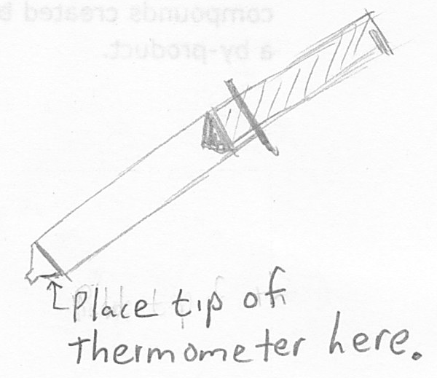
- Hold the syringe so that its tip is pointing down, and place the electronic thermometer against the bottom edge of the syringe (see picture to right). Wait for the temperature reading to stabilize. Keep the thermometer here until you reach step 15.
- Take the nail out of the syringe, and quickly push the plunger all the way to the bottom.
- Watch the thermometer.

Q17: How did the temperature change when you pushed the plunger down?

- Look at the bottom of the syringe.

Q18: What do you see at the bottom of the syringe? Where did this substance come from?

Data – fill in the table below
Part | We saw a . . . | This is called . . . | Thermal energy was . . .
A: Thymol | liquid become a solid |  | released
B: Dodecanol
C: Ethanol
D: Syringe w/ Pentane Gas

Questions
Q19: Fill in the chart below:
Solid
Liquid
Gas
Name: _________________
Energy is ________________
Name: _________________
Energy is ________________
Name: __________________
Energy is ________________
Name: __________________
Energy is ________________

Q20. In which phase changes is energy released?

Q21: What is generally happening to the molecules in these phase changes?

Q22: In which phase changes is energy absorbed?

Q23: What is generally happening to the molecules in these phase changes?

